Meditation Mondays
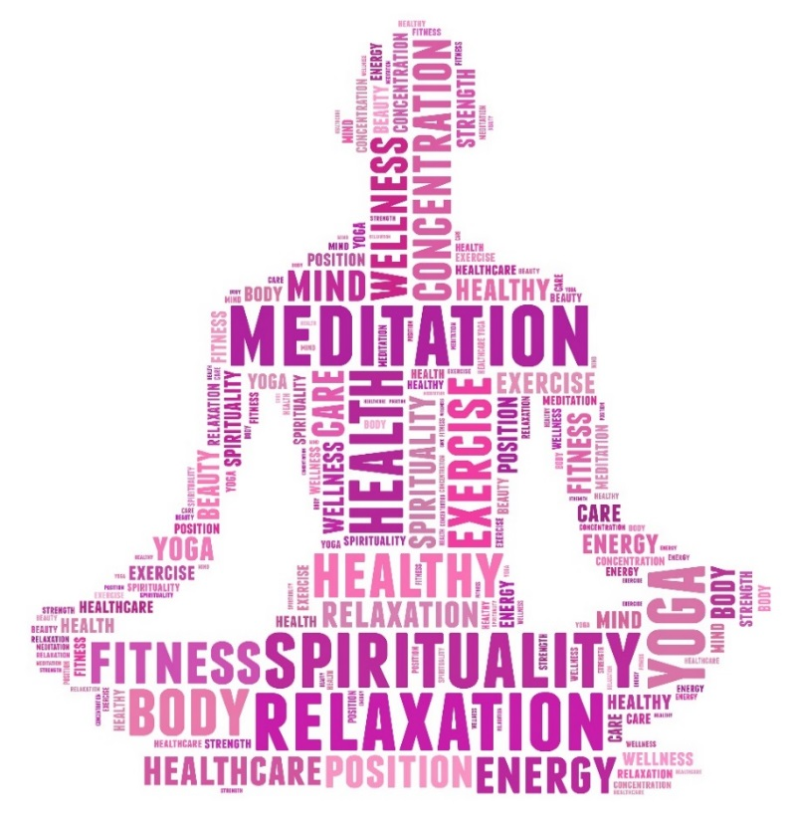
Start your week with meditation and breath-work to de-stress, clear the mind and create a sense of ease

Every Monday morning beginning October 7th 8:00am-8:15am

- Located in ASAP, PEB Room 356
- No Experience Necessary
- Sessions led by Rachel Najdzin, Academic Advisor
- Open to all staff, faculty and students

