

**SUMMER Webinar**

**Register at:**

Join us for a summer webinar on July 14th, 12 PM – 1 PM (CST) for a conversation on financial wellness and disability. Webinars are free to attend and free continuing education units (CEUs) are provided.

***Let’s start a conversation about money:***

***An introduction to financial wellness and disability***

**Wednesday, July 14, 12 PM – 1 PM (CST)**

****Presented by: Litany Esguerra, UIC-IDHD

**About the webinar:**

What is financial wellness? What does it mean for students with disabilities to achieve financial wellness? For students with disabilities, the hidden costs of living with a disability call for the need to consider what financial wellness and independence means during (and after) an individual attends college. There will be an interactive exercise and an exploration of some of the barriers, knowledge, and resources needed to achieve financial wellness.

**Who can attend:**

While this webinar was created with students/young adults and individuals with disabilities in mind, anyone else who wants to learn about more about financial wellness can attend!

NDI: National Disability Institute Logo
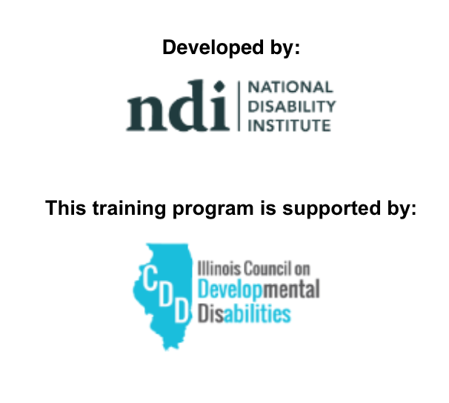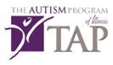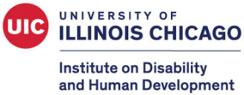

Funding provided in part by The Autism Program of Illinois and the Illinois Department of Human Services