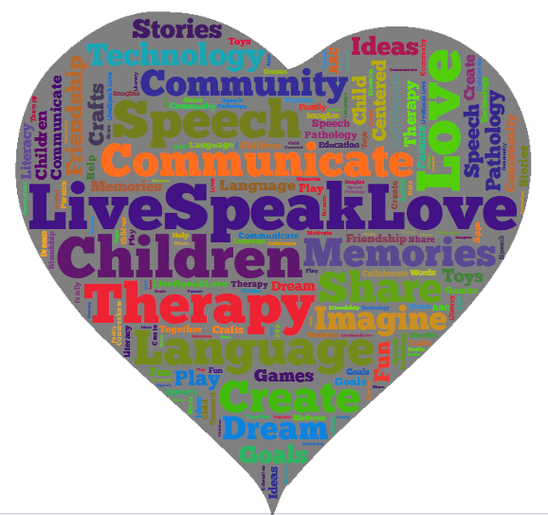Davies Middle School
MAY IS BETTER SPEECH AND HEARING MONTH
Help us to celebrate by joining us for a presentation that will focus on typical and atypical speech, language and communication development and disorders seen in children with Autism. You will learn functional strategies and interventions to incorporate into your daily routines and activities across a variety of environments.
*Funding for these seminars was generously provided by the National Greek Orthodox Ladies Philoptochos Society, Inc.
TARGET AUDIENCE: Parents/caregivers of children with Autism
WHEN: Friday, May 19th, 2017
WHERE: UIC Family Clinic 1640 W. Roosevelt Rd. 60608 Rm. 448
Time: 8:00 a.m. registration, workshop begins: 8:30-3:00 p.m.
COST: Totally Free
Space is limited! Register in advance by calling Sara Shields-Cole at 312/413-1486.
You can send any questions you may have regarding your child’s speech and language development by emailing Ms. Shields-Cole at scole@uic.edu
** Working lunch (provided)
**Street meters and paid parking lot on Taylor and Paulina

